WEEK – 3

Advanced Data Analysis and Visualization in Logistics

Student Name | Karan Singh
Internship Task | Week 3 – Advanced Data Analysis and Visualization in Logistics
Domain | Data Analysis & Visualization
Tools Used | Python, Pandas, NumPy, Matplotlib, Seaborn
Report Type | Technical Internship Report

1. Executive Summary
This week’s internship task focused on using Python to explore logistics data, identify useful patterns, and communicate findings through clear visualizations. The work was approached as a practical data-analysis exercise rather than only a programming task. A structured logistics dataset was prepared with information about shipments, product categories, transportation modes, quantities, weights, volumes, delivery times, and transportation costs.
The analysis followed a complete workflow: understanding the dataset, checking data quality, preparing the variables, calculating descriptive statistics, examining distributions and correlations, creating visualizations, and converting the observations into operational insights. Python libraries such as Pandas, NumPy, Matplotlib, and Seaborn were used because they provide a practical combination of data manipulation, numerical analysis, and visualization capabilities.
The main outcome was a clearer view of how shipment volume, transportation mode, delivery time, weight, volume, and cost are connected. The visual analysis also made it easier to identify regions and transportation modes that may require closer attention. The report ends with recommendations and a short reflection on how data analysis can support day-to-day logistics decisions.

2. Objective of the Task
- Explore and understand a logistics dataset using Python.
- Perform exploratory data analysis (EDA) to identify distributions, trends, relationships, and unusual observations.
- Calculate central tendencies such as mean and median and examine the distribution of important variables.
- Study correlations between shipment quantity, weight, volume, delivery time, and transportation cost.
- Create multiple visualizations using Matplotlib and Seaborn and justify why each chart was selected.
- Translate analytical results into practical logistics insights related to efficiency, cost, delivery performance, and possible bottlenecks.
- Document the complete process with Python code snippets, visual outputs, interpretations, and recommendations.

3. Logistics Dataset and Task Simulation
For this report, a sample logistics dataset containing 300 shipment records was prepared to demonstrate the complete analysis workflow. The fields were chosen to represent common information available in a logistics operation. The dataset includes shipment and order identifiers, region, product category, transportation mode, shipment date, quantity, weight, volume, delivery status, delivery time, and transportation cost.
Variable | Meaning
Shipment_ID | Unique shipment reference
Order_ID | Unique order reference
Region | Operational region of the shipment
Product_Category | Type of product being transported
Transportation_Mode | Road, Rail, Air, or Sea
Shipment_Date | Date on which the shipment was dispatched
Quantity | Number of units in the shipment
Weight_kg | Shipment weight in kilograms
Volume_m3 | Approximate shipment volume
Delivery_Time_Days | Time taken for delivery
Transportation_Cost | Estimated transportation cost
Status | Delivered, Delayed, or In Transit

4. Data Preparation and Quality Checks
Before interpreting the data, I treated data preparation as an important part of the analysis rather than something to do only at the end. The first checks included the dataset shape, column names, data types, missing values, duplicate records, and basic summary statistics.
- Imported the dataset with Pandas and inspected the first records.
- Checked data types and converted shipment dates into a proper datetime format.
- Detected 8 missing cells in the initial sample and handled numeric missing values using median imputation.
- Checked for duplicate shipment records and reviewed the numerical ranges for obvious data-entry issues.
- Created useful derived variables such as delivery time, month, and transportation cost per unit.
- Grouped records by region, product category, month, and transportation mode for comparison.

Example Python – Loading and Preparing the Data
import pandas as pd
df = pd.read_csv("logistics_data.csv")
df["Shipment_Date"] = pd.to_datetime(df["Shipment_Date"])
df["Delivery_Time_Days"] = (
pd.to_datetime(df["Delivery_Date"]) -
df["Shipment_Date"]
).dt.days
df["Cost_per_Unit"] = (
df["Transportation_Cost"] / df["Quantity"]
)
df.info()
df.isnull().sum()

5. Exploratory Data Analysis (EDA)
The EDA stage was used to move from raw records to an overall understanding of the logistics process. I looked at central tendencies, distributions, category frequencies, and relationships between numerical variables.
Metric | Result | Interpretation
Average delivery time | 4.53 days | Typical time required for a shipment
Median delivery time | 4.45 days | Middle value, less affected by extreme cases
Average transportation cost | ₹875.77 | Typical shipment transportation cost
Median transportation cost | ₹868.52 | Central cost level
Average cost per unit | ₹23.35 | Useful for comparing shipment efficiency
Delayed shipments | 20.3% | Share requiring operational attention

Central Tendency and Distribution
Mean and median were calculated for delivery time and transportation cost. Comparing the two helps indicate whether a small number of expensive or slow shipments are pulling the average upward. Frequency counts were also used for categorical variables such as region, product category, and transportation mode.

6. Visualizations and Interpretation
Different charts were selected for different questions. Bar charts were used for category comparisons, a line chart was used for the monthly trend, and a correlation heatmap was used to understand relationships between numerical variables. This keeps the visualization method connected to the analytical purpose.
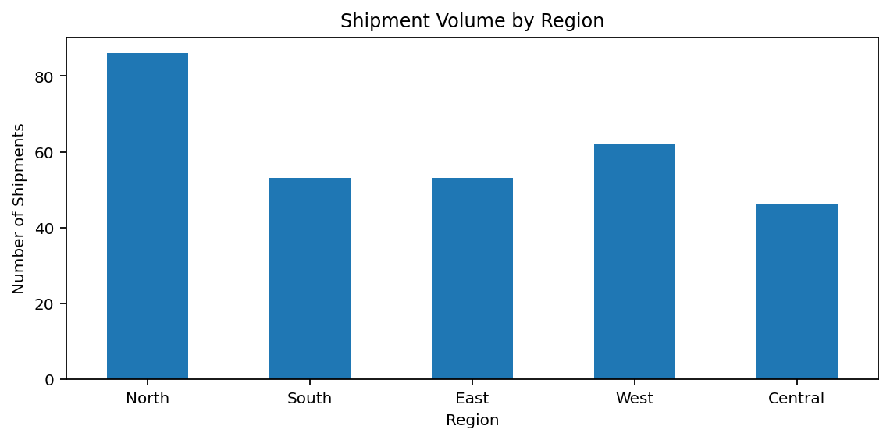
Figure 1. Shipment volume by region.
The regional comparison shows that North has the highest shipment volume in the sample, with 86 shipments. This suggests that operational capacity, warehouse planning, and route availability in high-volume regions deserve more attention than regions with relatively lower activity.
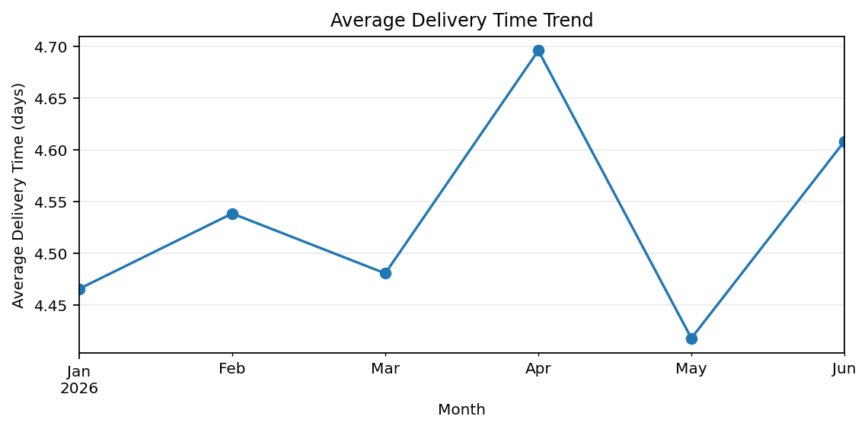
Figure 2. Average delivery time across the six-month period.
The monthly trend provides a quick view of delivery performance over time. A line chart is appropriate here because the order of months matters. Changes in the line can help an operations team investigate whether service performance is improving, remaining stable, or becoming less predictable.
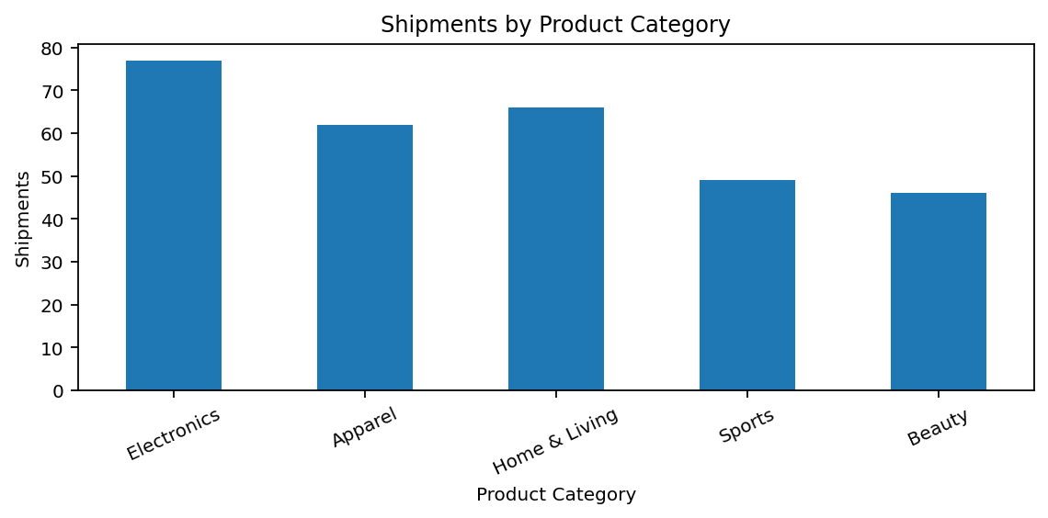
Figure 3. Distribution of shipments across product categories.
The product-category chart makes it easier to see which types of products contribute most to shipment activity. This information can support packaging decisions, warehouse space planning, and demand-based allocation of resources.
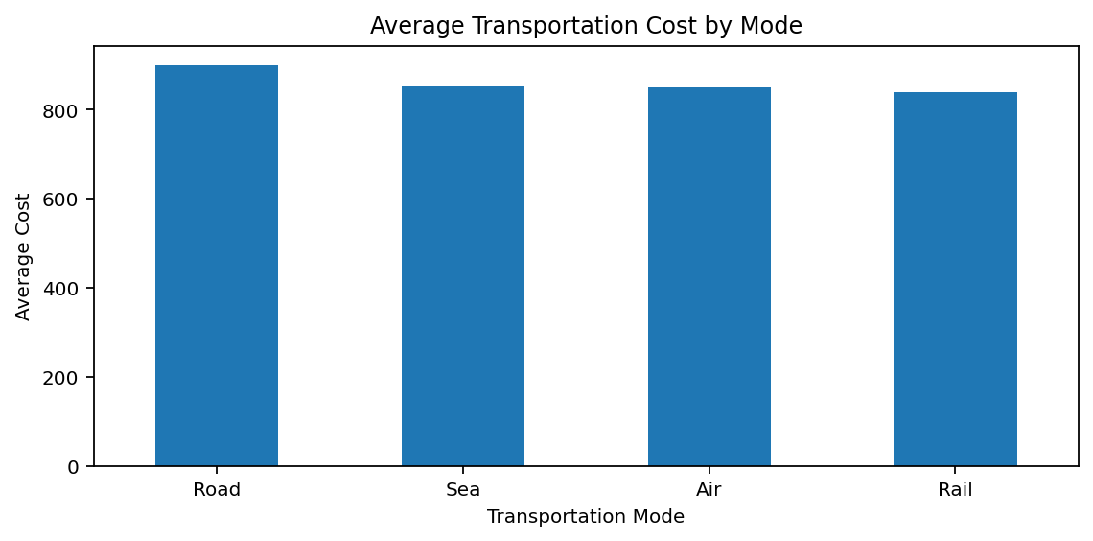
Figure 4. Average transportation cost by transportation mode.
The comparison of transportation modes highlights cost differences between Road, Rail, Air, and Sea. The chart should not be interpreted as a simple 'cheapest is always best' rule. Delivery urgency, distance, capacity, and service-level requirements also need to be considered before changing the transport mix.
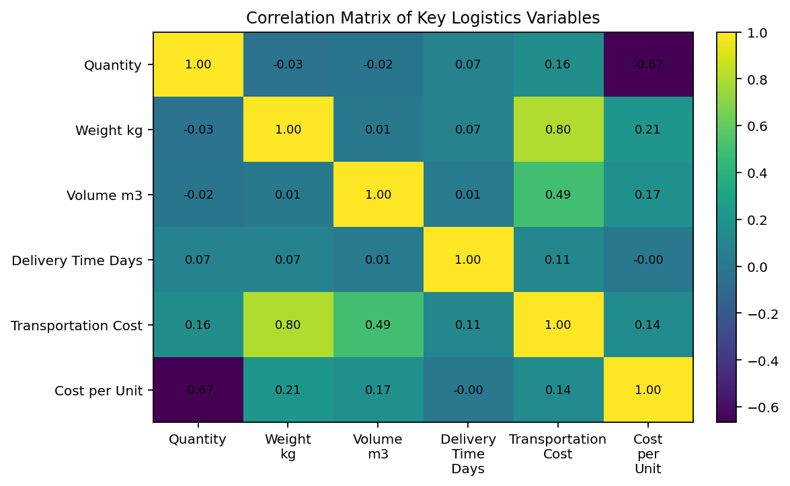
Figure 5. Correlation heatmap for key numerical logistics variables.
The heatmap summarizes the direction and strength of linear relationships. Weight, volume, quantity, and transportation cost show positive relationships in the sample, which is operationally reasonable because larger shipments generally require more transport capacity. Correlation does not prove causation, so these results should be combined with business knowledge before making a final decision.

7. Python Visualization Code

Bar chart for comparing shipment volume across regions.
# Shipments by region
region_counts = df["Region"].value_counts()
region_counts.plot(kind="bar", figsize=(8, 4))
plt.title("Shipments by Region")
plt.xlabel("Region")
plt.ylabel("Number of Shipments")
plt.show()

Line chart for identifying changes in delivery performance over time.
# Monthly delivery-time trend
monthly = df.groupby(
df["Shipment_Date"].dt.to_period("M")
)["Delivery_Time_Days"].mean()
monthly.plot(marker="o", figsize=(8, 4))
plt.title("Average Delivery Time Trend")
plt.xlabel("Month")
plt.ylabel("Average Delivery Time (days)")
plt.show()

Heatmap for examining relationships among numerical variables.
# Correlation heatmap
corr = df[[
"Quantity", "Weight_kg", "Volume_m3",
"Delivery_Time_Days", "Transportation_Cost"
]].corr()
sns.heatmap(corr, annot=True, cmap="coolwarm")
plt.title("Correlation Heatmap")
plt.show()

8. Analytical Insights
- North is the highest-volume region in the sample, so it may benefit from closer monitoring of route capacity and warehouse throughput.
- The average delivery time is approximately 4.53 days, while the median is 4.45 days. Comparing these values helps identify whether slower shipments are affecting the overall average.
- Transportation cost increases as shipment weight and volume increase, indicating that shipment size is an important cost driver.
- Road has the highest average transportation cost in the sample. Its use should therefore be connected to situations where its speed or capacity provides a clear operational benefit.
- Approximately 20.3% of sample shipments are marked as delayed. Even when the percentage is not dominant, repeated delays can affect customer satisfaction and inventory planning.
- Cost per unit is a useful additional metric because total shipment cost alone can make a large shipment appear inefficient when it may actually have a reasonable unit cost.
- The visualizations suggest that logistics performance should be monitored through a combination of delivery time, shipment volume, cost, and service status rather than through one metric alone.

9. Potential Bottlenecks
- High-volume regions can experience warehouse congestion or route capacity limitations if resources are not scaled with demand.
- Longer delivery times on specific routes or transportation modes can create service-level problems.
- Heavy or high-volume shipments can raise transportation costs and may require better consolidation or load planning.
- A higher-than-expected delay rate may indicate problems in route planning, carrier performance, warehouse processing, or last-mile coordination.
- Without consistent monitoring, operational teams may notice these issues only after they have already affected customers.

10. Recommendations
- Create a weekly dashboard covering shipment volume, average delivery time, delayed shipments, and transportation cost.
- Review high-volume regions regularly and compare their shipment growth with available warehouse and transport capacity.
- Use cost-per-unit alongside total transportation cost when evaluating carriers and transportation modes.
- Investigate repeated delays by route, region, carrier, and transportation mode instead of treating all delays as the same problem.
- Use historical shipment data to improve route planning and identify opportunities for consolidation.
- Maintain clean and consistently formatted data because reliable analysis depends on reliable input data.
- As the project grows, automate the reporting workflow so that new shipment data can be analyzed with minimal manual effort.

11. Documentation of the Analytical Process
The workflow used in this task can be summarized as: Data Collection/Creation → Data Cleaning → Data Exploration → Statistical Analysis → Visualization → Interpretation → Recommendations. Each stage was documented so that another person can understand how the final observations were obtained. The Python snippets included in this report are representative parts of the analysis and can be expanded into a complete notebook or .py file.

12. Learning Outcomes
- Improved practical understanding of Pandas for filtering, grouping, aggregation, and feature creation.
- Used NumPy for numerical operations and basic data preparation.
- Practiced Matplotlib and Seaborn for communicating analytical findings visually.
- Learned why missing-value handling and data-type validation are important before analysis.
- Understood the difference between describing data and interpreting what the data may mean operationally.
- Learned that a good visualization should answer a specific business question rather than simply make the report look attractive.
- Developed a more structured approach to turning raw logistics records into measurable insights and recommendations.

13. Conclusion
This internship task provided practical experience in applying Python to a logistics-focused data problem. The work covered the complete analytical cycle, from preparing the dataset and checking its quality to performing EDA, calculating summary measures, studying correlations, creating visualizations, and interpreting the results.
One of the most useful lessons from the task was that visualization is not separate from analysis. A well-chosen chart can make a trend, comparison, or relationship much easier to understand and can help convert technical results into information that an operations team can actually use. At the same time, numerical results need context; a correlation or average should not be treated as a final business decision without understanding the operational situation.
Overall, the project strengthened my confidence in using Python for exploratory data analysis and showed how data can support better decisions in logistics. The same approach can be extended to real company data, automated dashboards, predictive delivery-time models, and more detailed cost optimization in future work.

